**Innovative Healthcare Forecasting System: Anticipating and Preventing Tomorrow's Health Crises**

There is a need for an AI-driven system that aids doctors and healthcare providers in diagnosing diseases promptly and accurately. This system Figure 1 harnesses the power of computer vision, speech recognition, text-to-speech conversion, natural language processing (NLP), and data science.

Operating within the doctor's office, proposed system is designed to seamlessly facilitate patient examinations and inquiries. It boasts an array of sophisticated components, including two video cameras, two microphones, access to online health record servers, an online statistics system, and a powerful computing system. However, designing such expert system journey doesn't end with mere data collection. My research in eXplainable Artificial Intelligence (XAI), recognize a critical challenge faced by medical professionals worldwide “The lack of interpretability” in traditional machine learning models. These models often operate as black boxes, leaving doctors in the dark about the rationale behind their recommendations. Past efforts have primarily focused on achieving accuracy without delving into the underlying decision-making process. This opacity limits the practical utility of such models in real-world healthcare settings. But fear not, for proposed system has embarked on a quest to illuminate the shadows of uncertainty with the torch of XAI and the brilliance of large language models (LLMs). By unraveling the “why”, “what”, and “how” behind the model's predictions, system empower healthcare professionals with invaluable insights. Imagine a world where doctors not only receive predictions but also gain a deeper understanding of the specific patient characteristics driving those predictions. Armed with this knowledge, they can craft personalized and effective treatment plans tailored to each patient's needs. But wait, there's more! Proposed system doesn't just stop at individual patient care, it casts its gaze into the future, offering insights into the health trends of entire societies, particularly for specific age groups. With XAI by their side, doctors can confidently wield the predictions of AI models, secure in the knowledge that they are making informed decisions that will shape the future of healthcare.

**Sub-Systems:**

# Video streaming system

## For doctor

The system identifies the doctor's name and retrieves their profile and preferences from the database. This allows the system to understand the doctor's specialization and communication style, which in turn influences the output generated by Large Language Models (LLMs) to support the predicted outcome. For instance, it helps determine why a patient is coughing and how they might have contracted it, whether through poor diet or exposure to a prevalent virus in the community (analyzing recent patient data across hospitals in the region). Additionally, the system detects the doctor's level of fatigue and body posture, providing insights into their attentiveness to the patient's needs.

## For patient

System detects the symptoms of disease, see the level of pain through face expressions, body language. System also detect which part of body is injured and bleeding.

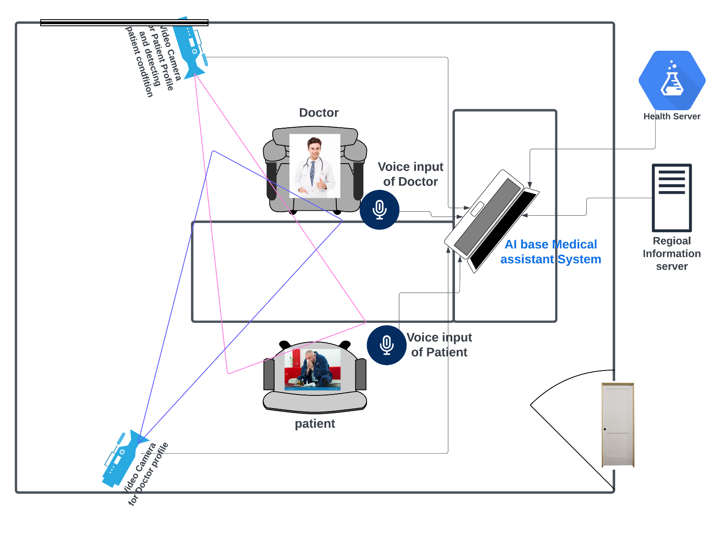

Figure 1: Medical Assistant System Layout

# Audio system:

Proposed AI assistant system require an audio system to capture conversations between doctors and patients. This sub-system plays a crucial role in providing valuable information about the disease. It enables proposed system to analyze the conversation, question-answers, disease symptoms and offer outputs and suggestions based on the information gathered from both microphones.

## For doctor:

The system identifies the doctor's tone and assesses their fatigue level using speech recognition tools such as Librosa and OpenSMILE. It employs a speech-to-text algorithm to understand the nature of the questions the doctor asks about the patient's condition. These questions play a crucial role in pinpointing the specific disease and understanding the patient's current heath condition.

## For patient:

The system listens to the patient's voice to gauge the level of pain they're experiencing. It then adjusts the neural node weights in black-box network accordingly to understand the crucial situation of patient in this disease. The system also interprets the patient's responses to the doctor's questions to grasp their true meaning based on the context. Additionally, it evaluates the patient's current condition and recommends what next question the doctor should ask to pinpoint the specific disease and its root cause.

# Previous history of patient:

The system aggregates patient history from both the current clinic and previously visited clinics, utilizing their social security number as a unique identifier. This comprehensive data collection process provides the system with insights into the patient's travel history, regional statistics from past locations, cultural nuances, body characteristics, blood sample analyses, and the state of vital signs and immune defenses in relation to the new environment, weather, work place, and new viral diseases. Leveraging this information, the system can predict potential diseases and offer tailored dietary plans to enhance the patient's immune system, fostering better health outcomes.

# Global statistics:

The system gathers data on various factors including weather conditions, prevailing levels of anxiety and depression within the community, workplace stress levels, economic indicators at both regional and national levels, relationship dynamics, social behavior patterns, and online statistics pertaining to the selected region. This wealth of information enables the system to discern prevalent viral infections and identify the specific vitamins and minerals required to bolster the body's defenses against these infections. Moreover, it empowers the system to anticipate future disease outbreaks and project the potential patient ratio within the community, facilitating proactive healthcare measures.

This proposed system in the medical field helps doctors understand diseases and the local environment to prevent illnesses and future health problems. It creates personalized dietary plans for each person based on their body, medical history, and workplace, promoting a healthier lifestyle. The system also forecasts future disease rates and predicts how much medicine will be needed to handle medical emergencies.